CLOSES PATH FINDER

Definition:

This project aims to demonstrate how search algorithms function in maze-like environments, helping users visualize and understand the process of finding optimal paths from one point to another. It provides an interactive way to explore different search strategies and their effectiveness in various scenarios. The user selects a search algorithm , starting and ending points and walls . The application finds the shortest path considering the walls and input taken by the user. After finding the shortest path the path is being highlighted. And the steps are being shown.

metin, ekran görüntüsü, yazılım, sayı, numara içeren bir resim

Açıklama otomatik olarak oluşturuldu

# Requirement 1:

R1.There will be 9 rooms in the game. (They will be located in 3x3 structure as given in example)

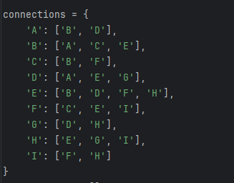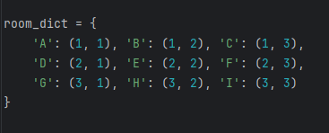

REQUIREMENT 2:

R2.The source and goal rooms will be given by the user. Example : Source= A, Goal =C in given figure.

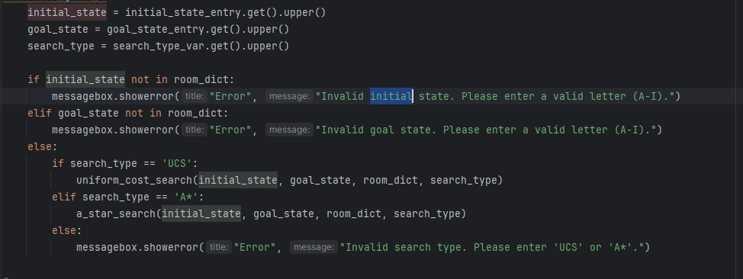,

REQUIREMENT 3:

R3.The walls between the rooms will be given by the user.

metin, ekran görüntüsü, yazılım, multimedya yazılımı içeren bir resim

Açıklama otomatik olarak oluşturuldu

REQUIREMENT 4:

R4.The robot can be moved up, down, right, or left.

metin, ekran görüntüsü, yazılım, yazı tipi içeren bir resim

Açıklama otomatik olarak oluşturuldu

REQUIREMENT 5: .

The user will choose one of the search strategies: uniform cost and A* search (use Hamming distance as heuristics).

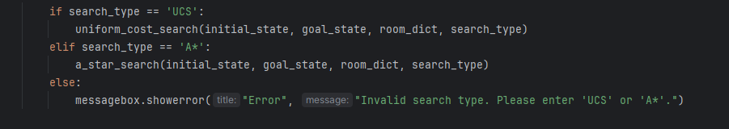

REQUIREMENT 6:

The searching will go on till 10th expanded node. The program will print out each expanded state and compare it with the given goal state.

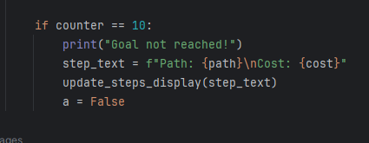

ALGORITHM EXECUTION:

A* search

Initial state : B

Goal state: I

Walls : B-E , E-F

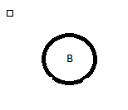Step 1:

Fringe - [[3, 'B']]

Expanded Node: B

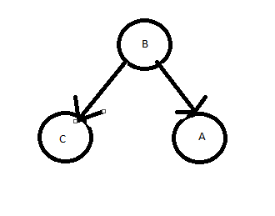

Step 2:

Fringe - [[4, 'BC'], [6, 'BA']]

Expanded Node: C

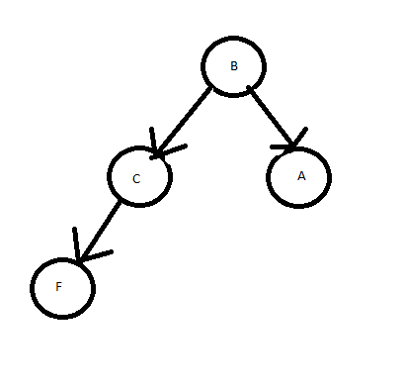Step 3:

Fringe - [[4, 'BCF'], [6, 'BA']]

Expanded Node: F

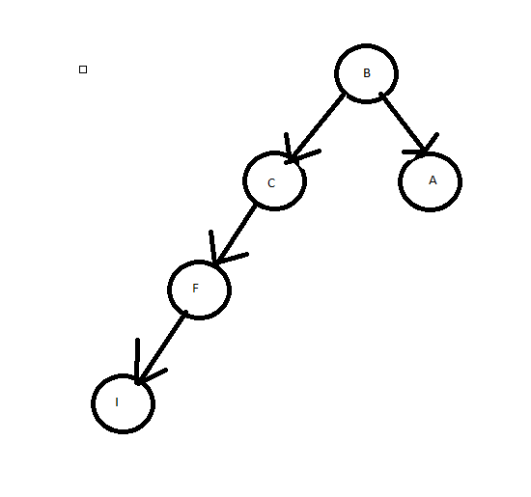Step 4:

Fringe - [[4, 'BCFI'], [6, 'BA']]

Expanded Node: I